Noida Institute of Engineering & Technology, Greater Noida
(Session: 2025 - 26)


Global Causes of Death Analysis (1990–2019)
Global Causes of Death Analysis Dashboard using Tableau
DATA ANALYTICS PROJECT REPORT
Data Analytics Workshop

Submitted By :- Submitted to :-
Name :- Drishay Chauhan Professor Vivek Kumar
Roll no. :- 2301330100084
Branch :- CSE
Year :- Third

NOIDA INSTITUTE OF ENGINEERING & TECHNOLOGY
Department of Computer Science & Engineering

Date of Submission :- 17-03-2026
Abstract

The Global Causes of Death Analysis Dashboard is designed to provide a comprehensive overview of mortality trends across countries, diseases, and time. In the modern world, health-related data plays a crucial role in understanding disease burden, public health challenges, and long-term mortality patterns. This project aims to analyze and visualize death statistics from 1990 to 2019 using Tableau in order to identify major causes of death, compare country-wise impact, and observe trends over time.
The dashboard integrates multiple data dimensions such as total deaths, number of countries, disease categories, and yearly death trends to present a broad and meaningful picture of global mortality. By using Tableau’s interactive data visualization features, complex health datasets are transformed into clear, intuitive, and insightful visual representations.
One of the key features of the dashboard is the analysis of the top 10 deadliest diseases worldwide. This helps in identifying which disease groups have had the greatest impact on human life across the selected period. The time-series trend chart further enables users to observe how deaths related to different diseases have changed over the years, helping reveal growth patterns, stability, or decline in mortality.
The dashboard also includes a global disease map and a country comparison section, which help in understanding geographical variations in disease burden. These features make it easier to identify countries with high mortality counts and compare the influence of diseases across major nations. In addition, the heatmap offers a compact comparative view of disease intensity across countries, allowing users to detect concentration patterns efficiently.
Overall, the project demonstrates how data analytics and visualization can help simplify large-scale health data and support better understanding of worldwide mortality patterns.

Introduction

Background

Health and mortality data are among the most important indicators of a nation’s social and economic condition. Across the world, millions of deaths occur each year due to communicable diseases, non-communicable diseases, and other health-related causes. Tracking these causes over long periods helps researchers, policy-makers, and health organizations understand changes in global disease burden and prepare better healthcare strategies.
With the increasing availability of global datasets, data analytics has become essential in transforming raw health records into meaningful insights. Traditional statistical reports may contain important information, but they are often difficult to interpret quickly. Therefore, interactive dashboards and visual analytics tools like Tableau are increasingly used to convert large and complex datasets into understandable visual formats.
The Global Causes of Death Analysis project focuses on mortality data from 1990 to 2019 and presents it through a dashboard that allows users to explore disease patterns across years and countries. By examining this information visually, users can better understand how various diseases have impacted populations worldwide.

Importance of Data Analytics in Social Media

Data analytics plays a significant role in healthcare and public health research. It helps identify disease trends, compare health outcomes across regions, and measure the long-term effects of different illnesses on populations. Through analytics, hidden patterns in mortality data can be discovered more effectively than through manual observation alone.
For governments and healthcare organizations, these insights are extremely valuable. They help in prioritizing health resources, planning disease prevention strategies, and identifying regions or disease categories that require urgent attention. By analyzing cause-of-death data across countries and years, decision-makers can better understand where interventions are needed most.
Visualization tools such as Tableau enhance this process by turning numerical data into interactive charts, maps, and comparison views. This makes complex mortality data easier to interpret and supports more informed, evidence-based decision-making in healthcare.

Purpose of the Study

The primary purpose of this project is to develop an interactive Global Causes of Death Analysis Dashboard using Tableau that provides a broad overview of mortality data from 1990 to 2019. The dashboard is intended to help users analyze deaths by disease, compare countries, and observe changes in mortality over time.
This project aims to present key indicators such as total deaths, total countries, total diseases, and latest year covered in the dataset. It also seeks to provide meaningful visual analysis through charts such as top deadliest diseases, yearly death trends, geographical disease distribution, country comparison, and disease heatmaps.
By integrating these multiple perspectives into one dashboard, the project enables a clearer and more holistic understanding of global mortality patterns and supports analytical exploration of worldwide health challenges.

Results

Graph 1: KPI Summary Cards

The dashboard begins with summary indicators that present the key highlights of the dataset. These include total deaths, total countries, total diseases, and the latest year available in the selected view. These KPI cards provide a quick overview of the scale and coverage of the analysis and help users immediately understand the magnitude of the dataset.

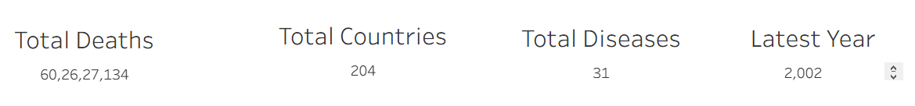

Graph 2: Top 10 Deadliest Diseases Worldwide

This bar chart displays the ten diseases responsible for the highest number of deaths globally. It allows easy comparison between major disease categories and highlights the dominance of certain causes of death over others. From the dashboard, cardiovascular diseases appear as the leading cause of death, followed by neonatal disorders, chronic respiratory diseases, and other major health conditions.

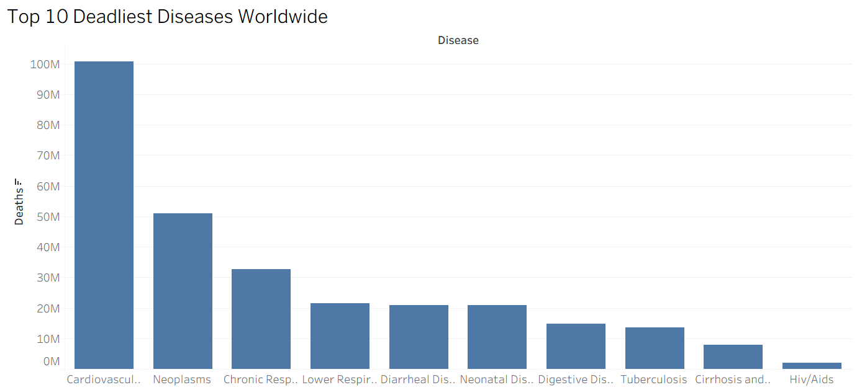

Graph 3: Death Trends Over Time
The line chart shows how deaths related to different diseases have changed across the selected years. This visualization is useful for tracking long-term mortality patterns and identifying whether certain diseases are increasing, stable, or declining over time. It provides an analytical view of how global health burdens evolve from year to year.

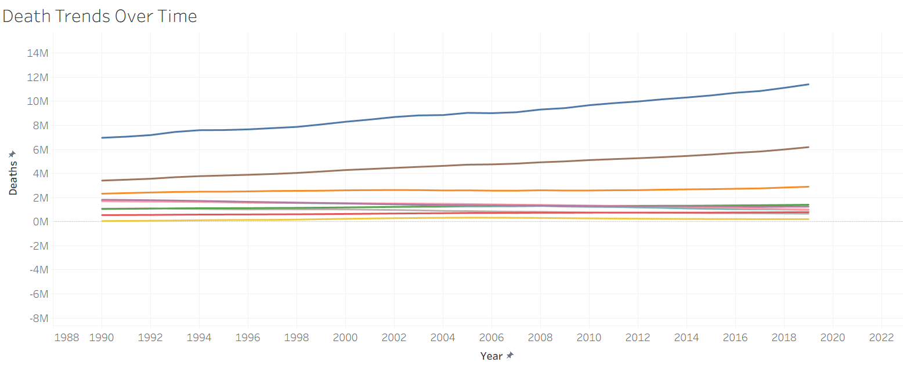

Graph 4: Global Disease Map

The geographical map presents country-level death distribution across the world. It helps visualize how mortality is spread globally and which countries contribute the largest number of deaths. Countries with darker shades represent higher death counts, making it easier to identify regions with significant disease burden.

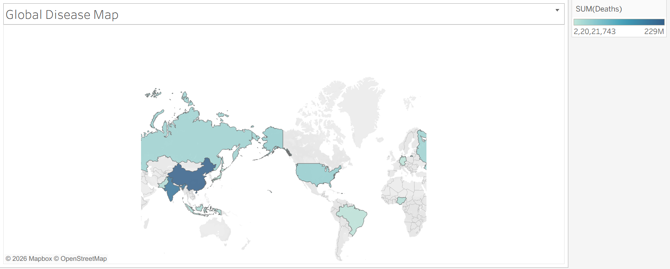

Graph 5: Country Comparison by Disease
This horizontal bar chart compares death totals across selected countries. It provides a straightforward ranking of countries based on mortality levels and helps users understand which nations are most affected in the dataset. In the displayed dashboard, countries such as China, India, and the United States show significantly higher total deaths compared to others.

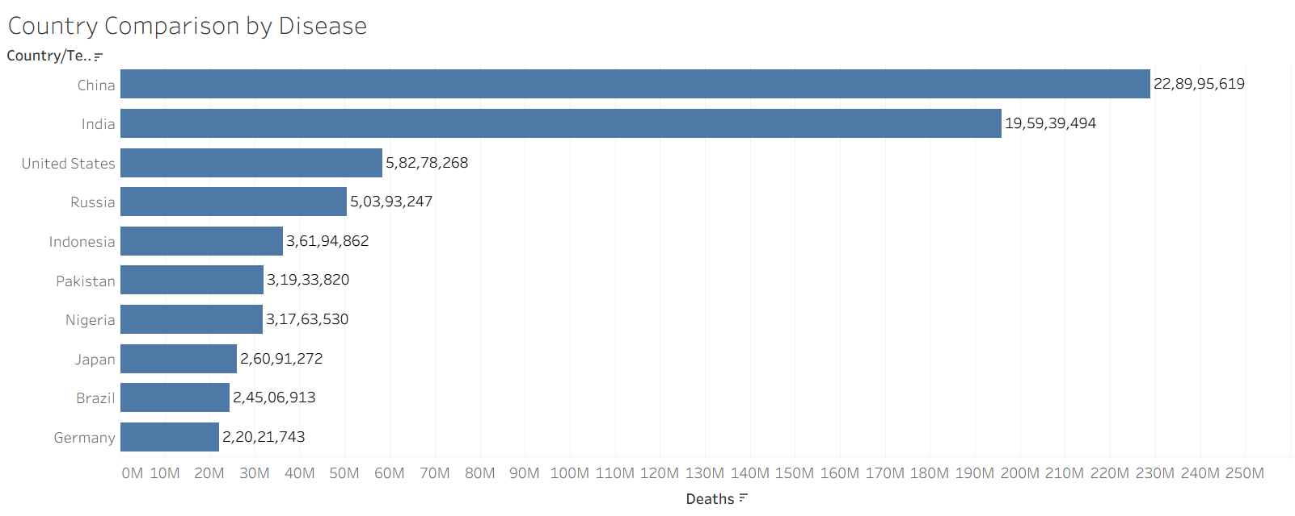

Graph 6: Disease Heatmap

The heatmap offers a compact comparative analysis of diseases across multiple countries. Different intensity levels represent variations in death counts for each disease-country combination. This chart is especially useful for identifying disease concentration patterns and spotting which diseases are more prominent in specific countries.

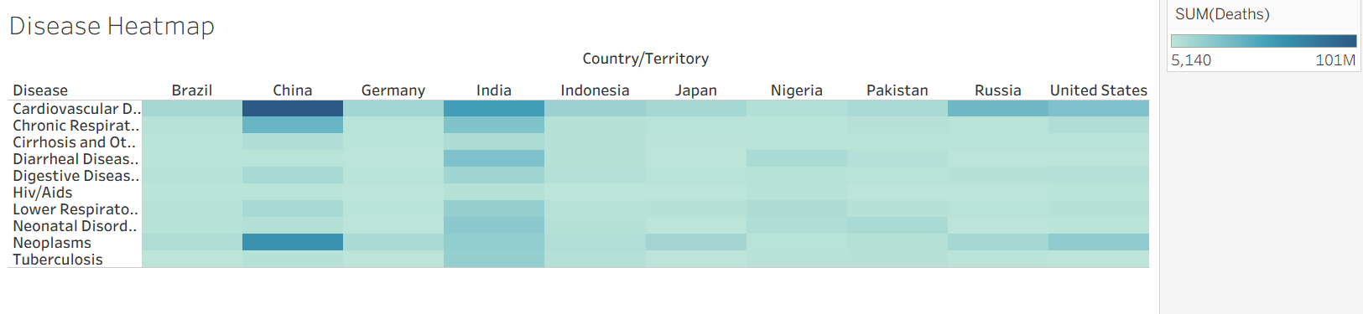

Dashboard

The complete dashboard combines all these visual elements into an interactive analytical interface. Filters for disease, country/territory, and year allow users to customize the analysis dynamically. By bringing together summary indicators, trend analysis, geographical mapping, and comparative charts, the dashboard provides a unified and insightful view of global causes of death.

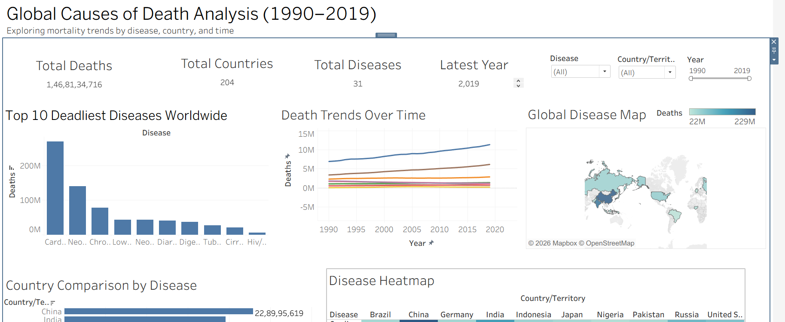

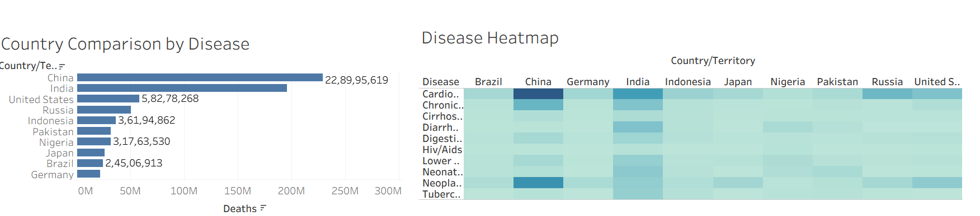

Summary
The Global Causes of Death Analysis Dashboard project focuses on analyzing and visualizing mortality data across different diseases, countries, and years from 1990 to 2019. The primary objective of this project was to transform raw global health data into meaningful insights using Tableau, enabling a better understanding of worldwide death patterns and disease burden.
The dashboard incorporates several important metrics such as total deaths, number of countries covered, number of disease categories, and year-wise trends. These indicators were used to provide both a summary and a detailed analytical view of mortality. Through the use of interactive visualizations such as bar charts, line graphs, geographical maps, and heatmaps, the project presents a comprehensive overview of how deaths vary by disease type, country, and time.
One of the major components of the dashboard is the top 10 deadliest diseases analysis, which highlights the diseases responsible for the largest share of deaths worldwide. This helps in identifying the most critical global health challenges. The time trend analysis further reveals how mortality patterns have evolved over the years, allowing users to study long-term shifts in the impact of different diseases.
The country comparison section enhances the analysis by showing which nations contribute most significantly to total deaths. Similarly, the global disease map provides a geographical representation of mortality distribution, making it easier to identify high-burden regions. The heatmap adds further analytical depth by allowing disease-wise comparison across multiple countries in a compact visual form.
Overall, the project demonstrates the effectiveness of data visualization in simplifying complex global health datasets and presenting them in a clear and understandable format. By integrating multiple dimensions of mortality analysis into a single dashboard, the project successfully provides a holistic view of global causes of death and emphasizes the importance of analytical tools in public health research.

Conclusion
In conclusion, the Global Causes of Death Analysis Dashboard successfully demonstrates how data analytics and visualization techniques can be used to derive meaningful insights from large-scale mortality data. By analyzing deaths across different diseases, countries, and years, the project provides a clear understanding of worldwide health patterns and the relative burden of major diseases.
The findings indicate that some disease categories, especially cardiovascular diseases, account for a significantly larger share of global deaths than others. The analysis also shows that mortality burden is not evenly distributed across countries, with highly populated nations such as China and India contributing prominently to the total death count. This highlights the importance of considering both population scale and disease prevalence in global health analysis.
The trend analysis over time reveals that deaths from major diseases show noticeable variation across years, emphasizing that mortality is influenced by long-term demographic, medical, and socio-economic factors. The geographical and comparative views further reinforce the importance of region-specific healthcare planning and targeted public health policies.
This project also showcases the power of Tableau as a data visualization tool in converting complex healthcare datasets into interactive and insightful dashboards. The ability to filter by year, disease, and country makes the analysis more flexible and user-friendly, thereby improving data exploration and interpretation.
In future work, the dashboard can be enhanced by incorporating more recent data, additional health indicators, predictive analytics, and deeper regional drill-down capabilities. These improvements would provide even richer insights and further strengthen the usefulness of the dashboard for healthcare analysis and decision-making.
Overall, this project reinforces the significance of data-driven approaches in understanding global mortality trends and highlights the role of visualization tools in supporting better public health awareness, planning, and strategy.

Noida Institute of Engineering & Technology, Greater Noida
(Session: 2025 – 26)


Sales Performance Dashboard
Sales Performance Dashboard using Tableau
DATA ANALYTICS PROJECT REPORT
Data Analytics Workshop

Submitted By :- Submitted to :-
Name :- Drishay Chauhan Professor Vivek Kumar
Roll no. :- 2301330100084
Branch :- CSE
Year :- Third

NOIDA INSTITUTE OF ENGINEERING & TECHNOLOGY
Department of Computer Science & Engineering

Date of Submission :- 17-03-2026

Abstract

The Sales Performance Dashboard project aims to analyze and visualize sales and profit data across different regions, segments, and product categories. In today’s competitive business environment, organizations rely heavily on data-driven insights to monitor performance, identify trends, and make strategic decisions. This project leverages Tableau to transform raw sales data into an interactive and visually appealing dashboard that provides a comprehensive overview of business performance.
The dashboard incorporates key performance indicators such as total sales, profit, sales trends over time, and distribution across customer segments and product categories. By integrating multiple visual elements, including scatter plots, line charts, bar graphs, and pie charts, the dashboard enables users to explore relationships between sales and profit, track growth patterns, and compare performance across different dimensions.
One of the key highlights of the dashboard is the analysis of sales trends over time, which helps in identifying seasonal variations and growth patterns. Additionally, the segmentation analysis provides insights into how different customer groups contribute to overall sales. Regional profit analysis further enhances understanding by highlighting geographical performance differences.
The project demonstrates the effectiveness of data visualization in simplifying complex datasets and supporting business decision-making. It provides valuable insights that can help organizations optimize sales strategies, improve profitability, and identify high-performing areas.

Introduction

1.1 Background

Sales data is one of the most critical assets for any organization, as it directly reflects business performance and growth. With increasing competition and rapidly changing market conditions, businesses generate large volumes of transactional data that need to be analyzed effectively. This data includes information about sales, profits, customer segments, product categories, and regional performance.
Traditional methods of analyzing sales data often fail to capture complex patterns and relationships. Therefore, modern data visualization tools like Tableau are used to convert raw data into interactive dashboards. These dashboards allow users to quickly understand trends, identify problem areas, and make informed decisions.

1.2 Importance of Data Analytics in Social Media

Data analytics plays a vital role in improving sales performance by uncovering hidden patterns and trends. It helps organizations understand which products are performing well, which regions generate the highest profits, and which customer segments contribute the most to revenue.
By analyzing sales and profit relationships, businesses can identify areas where high sales do not necessarily lead to high profits. Additionally, time-based analysis enables organizations to detect seasonal trends and adjust their strategies accordingly. Data visualization further simplifies this process by presenting complex data in an intuitive and interactive format.

Purpose of the Study

The primary purpose of this project is to develop an interactive Sales Performance Dashboard using Tableau that provides a detailed analysis of sales and profit data. The dashboard is designed to help users explore various aspects of business performance, including sales trends, regional profitability, customer segmentation, and product category analysis.
The project aims to support decision-making by presenting key insights through visualizations such as sales vs profit analysis, sales trends over time, and category-wise comparisons. By integrating multiple dimensions of analysis, the dashboard provides a holistic view of business performance.

Results
Graph – 1
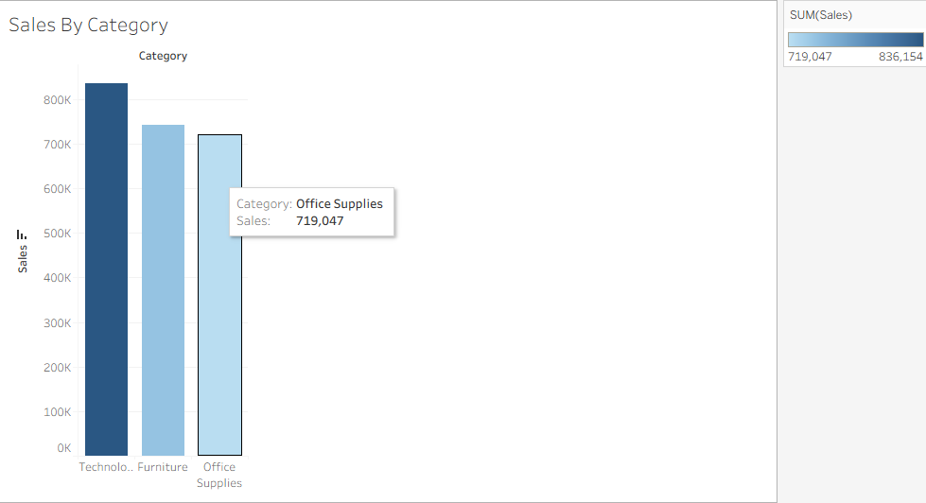

Graph – 2

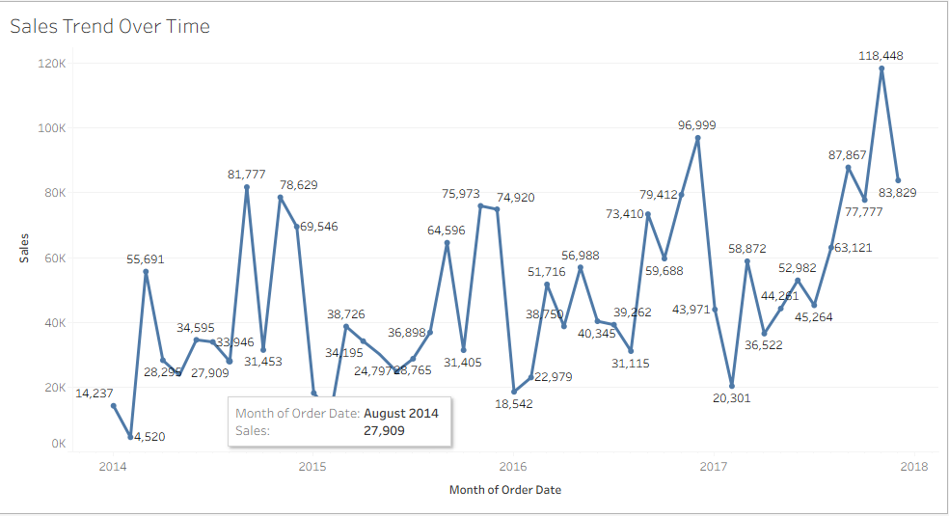

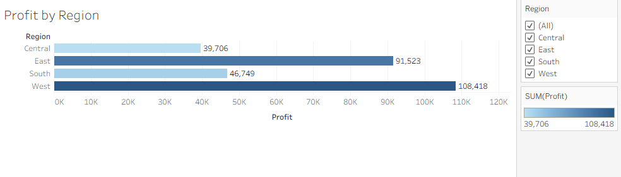
Graph – 3

Graph – 4

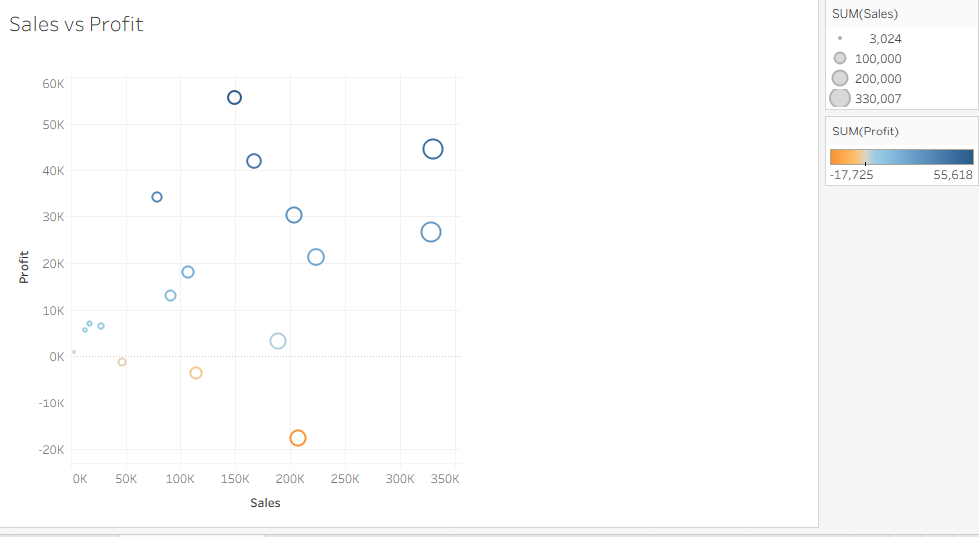

Graph – 5

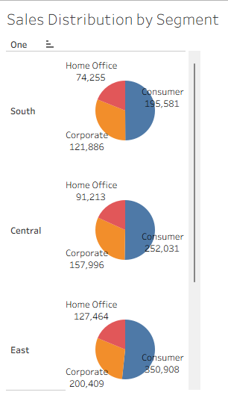

Graph – 6

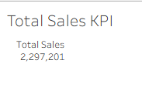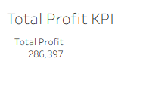

Dashboard

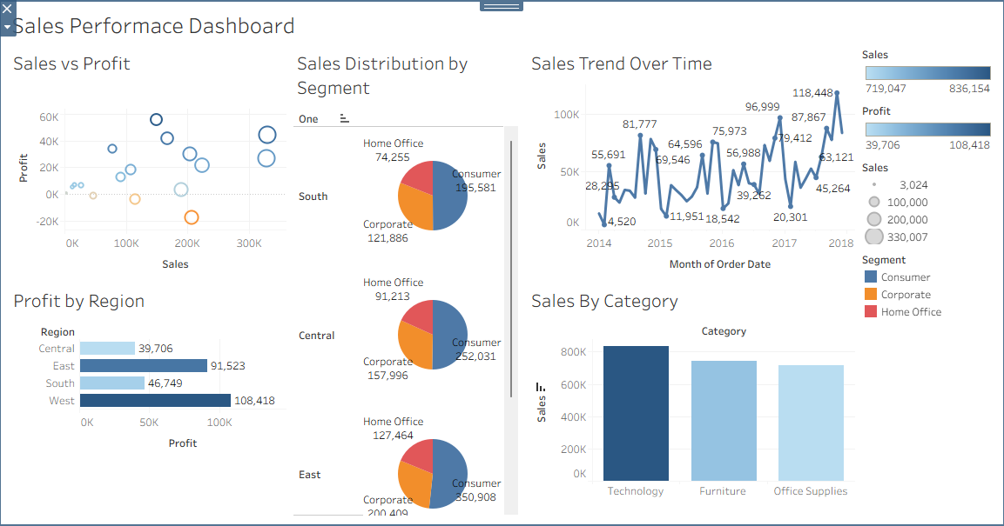

Summary

The Sales Performance Dashboard project successfully demonstrates how data visualization can be used to analyze and interpret business data effectively. By combining multiple visual elements into a single dashboard, the project provides a comprehensive overview of sales and profit performance.

The dashboard highlights key insights such as the dominance of the Consumer segment, the strong performance of the Technology category, and regional variations in profitability. It also emphasizes the importance of analyzing both sales and profit together to gain a complete understanding of business performance.

The inclusion of time-based analysis allows users to identify trends and patterns that can influence strategic decisions. Additionally, the interactive nature of the dashboard enables users to explore data from different perspectives, making it a powerful analytical tool.

Overall, the project showcases the importance of data-driven decision-making in improving business performance and optimizing sales strategies.

Conclusion
In conclusion, the Sales Performance Dashboard effectively demonstrates the role of data analytics and visualization in understanding and improving business performance. By analyzing key metrics such as sales, profit, customer segments, and product categories, the project provides meaningful insights into organizational performance.
The findings indicate that while sales are an important indicator of success, profitability must also be considered to ensure sustainable growth. The variation in performance across regions and segments highlights the need for targeted strategies to maximize efficiency and revenue.
The dashboard also emphasizes the importance of identifying high-performing categories such as Technology, which significantly contribute to overall sales. Additionally, the analysis of sales trends over time provides valuable insights into business growth and seasonal patterns.
Future enhancements of the project may include the integration of real-time data, predictive analytics, and advanced filtering options to provide deeper insights. Overall, this project reinforces the importance of using data visualization tools like Tableau to support informed decision-making and drive business success.

